The Pelosi Family
Ice cream and the beach – they go hand in hand, don’t they?
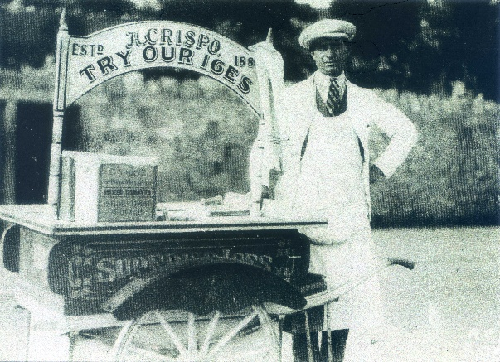
This picture from our archive is of an ice cream seller on Paignton Sands in the 1950’s. He is selling H. Crispo ice cream (established 188?) and sold in cornets made locally in Flora Street, Plymouth.

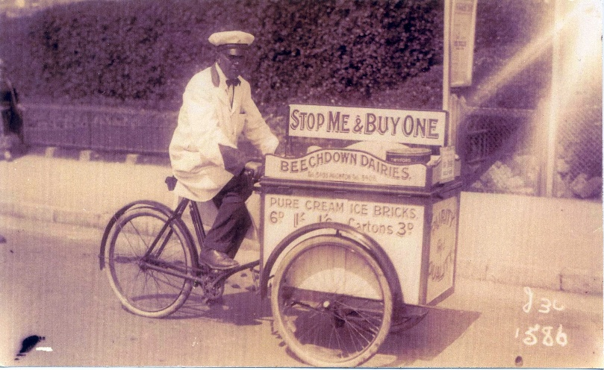

Then we have a photo of another street vendor, this time from the Beechdown Dairies of Paignton, with his slogan “stop me and buy one”. He is advertising “pure cream ice bricks – 6d, 1/-, 1/6d or cartons 3d”.

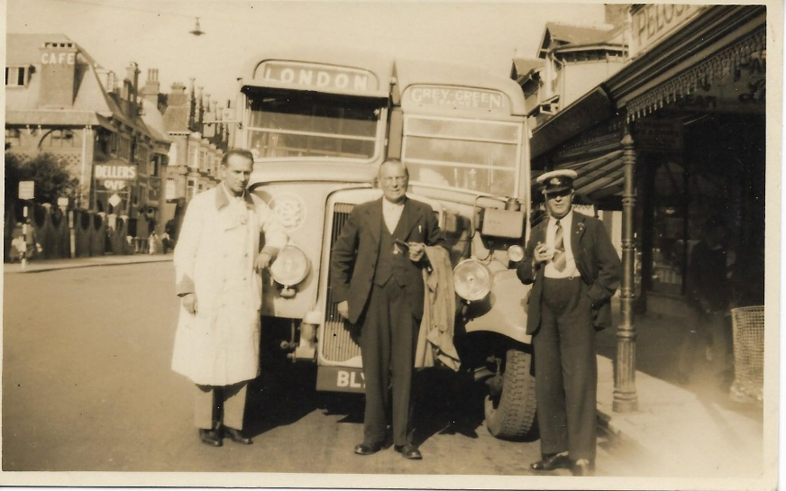
But now we move on to the real ice cream name – Pelosi. This 1950 photo shows a bus from London pulled up outside the Pelosi shop in Torbay Road. The gentleman in the centre is probably one of the Pelosi brothers, and on the left in the background is the lovely Dellers Café.
The story of the Pelosi family begins in 1903, when Pietro (Peter) Pelosi came to Paignton from Italy with his wife, Melania. Peter and Melania had six sons and a daughter, and they started making ice cream in the back room of Rose Cottage in Fisher Street.
Three things differentiate Italian “gelato” from American ice cream:
1. It is lower in fat – contains less cream and more milk
2. Serving temperature – it is served slightly warmer (minus 11C / minus 14C) which enhances texture and flavour
3. Artisanal tradition – it is made daily with fresh, high quality (often local) ingredients.

A tale told in Peggy Parnell’s ‘A Paignton Scrapbook’ relates how:
“Peter acquired a beautiful horse, which he bought from the Army surplus stores at the end of WW1. It was an exquisite animal with a stamp on its rump, and may well have once been a racehorse, for it certainly moved very fast.”
One day, Paignton was brought to a standstill. “Peter raced along Winner Street ringing his bell vigorously and shouting. Suddenly he reigned the galloping horse right into Church Street, shouting at anyone to get out of his way.
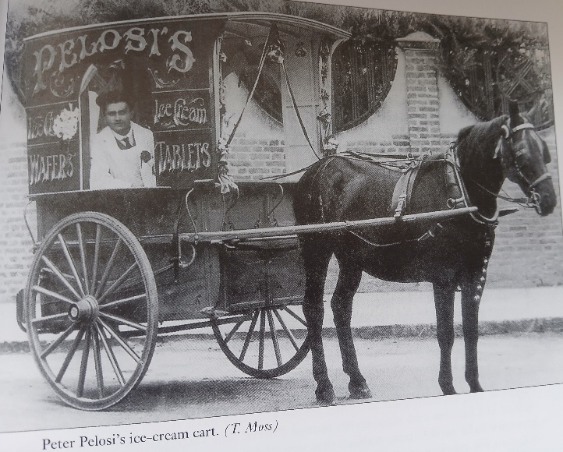
It turned out that Peter came home to find his wife bathing the children, steam and soaps everywhere, when suddenly the baby slipped out of her mother’s arms into a scalding hot bath. Grabbing his little daughter, Peter got into his cart and drove the horse as hard as he could. In those days there were no cars, no traffic lights and no halt signs, so like Ben Hur he galloped through the streets and, of course, a horse doesn’t have brakes, so it was a case of ‘Stand back everybody’. Fortunately, nobody was killed and mercifully he got his little girl to hospital in time and all was well.”
In the 1930’s the family business moved to open an ice cream parlour at 55 Torbay Road (three or four shops down from Andrews the Chemist on the corner of Garfield Road).
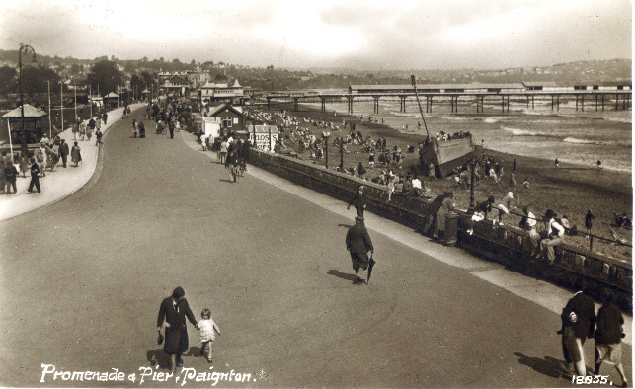
One son, Joe, worked alongside his brothers and sister in the family business which was part of Paignton’s youth culture for a generation.
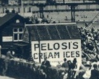

The ice cream business was so successful that it spawned other Pelosi ice cream parlours throughout Torbay. Joe worked with his brother Louis in Torquay, and later opened a shop in Brixham.
During the war, Joe served in the army and worked in bomb disposal. At that time, some people became suspicious of anyone with a foreign sounding name. My aunt told me that Mrs Pelosi had a big sign made for the front window of the Torbay Road parlour that announced –
6 sons – and all fighting for England

One of the Pelosi boys “fighting for England” was Ernest. He was called up when he was 18 and joined the Army. Two years later he lost his leg fighting in Italy, and returned to Devon, spending many months at the Manor House in Moretonhampstead, which had been turned into a hospital where Ernest was very popular with his fellow patients, especially when tubs of ice cream were delivered from his father.
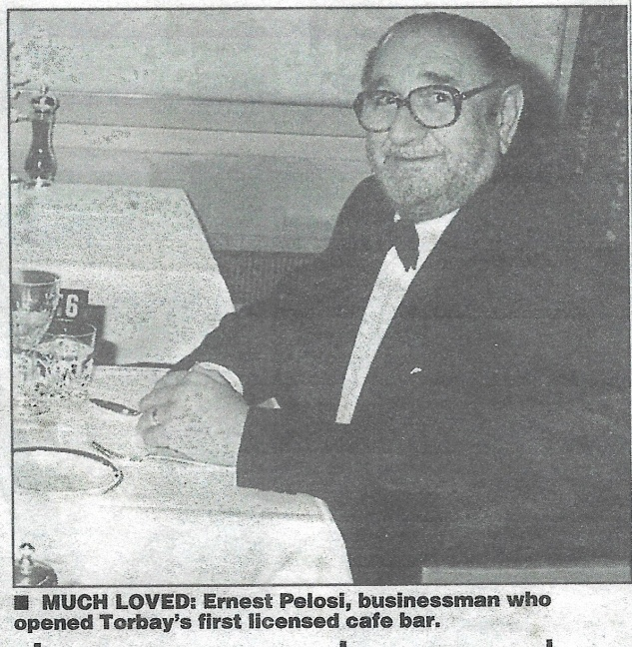
Ernest returned to the family business, working in and building up the ice cream parlour and tea room in Torbay Road. In the early 1970’s he expanded the business and opened La Taverna, also in Torbay Road, one of the first licensed café bars in the town. He retired in the late 1980’s.
Ernest was as busy in retirement as he was in business. Every morning he would swim, even though he suffered terribly with his artificial leg – he always saw the good side of people.
Throughout his life, Ernest volunteered and was involved with many good causes locally – the list reads like a CV

- Chair of SW Division of the Ice Cream Alliance
- President of the Catenians, an association of Catholic businessmen
- Member of the Rotary Club
- Founder member of the twinning association between Torbay and Hamelin and Honorary Life President
- Chairman of the Paignton Club and member of the Beefeaters
- President of Torbay Catering Association
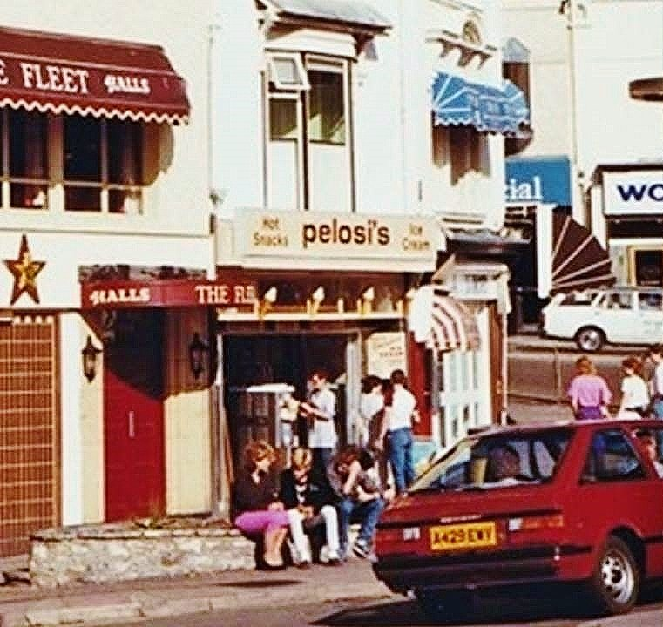
Ernest died in November 2002.
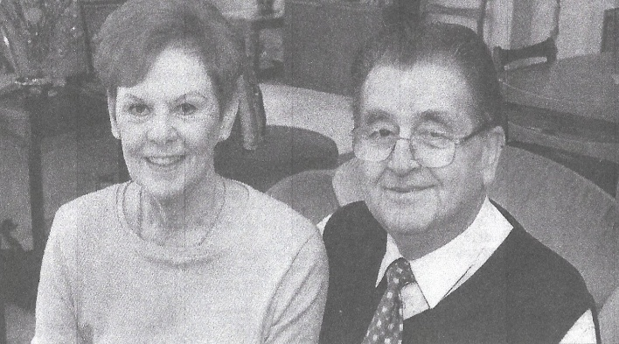
Another of the brothers was John. He was the youngest of the Pelosi boys and he sold ice cream in the summer and chips in the winter from his horse and cart. By now the horse was Dolly – a much calmer horse than Peter’s. John went on to run the family’s ice cream parlour in Abbey Place, Torquay, for many years until it was demolished to make way for Fleet Walk. He and his wife, Sue, also ran a shop in Brixham before they retired.
John is described as ‘the perfect gentleman – all the girls loved him and he was a great cuddly teddy bear of a man’. Like his brother, Ernest, John devoted much of his time to raising thousands of pounds for charities, particularly Tenovus cancer charity. John was also a keen sportsman, playing in the Paignton colts’ rugby club in the late 1940’s, and supporting both Torquay’s cricket and rugby clubs. John died in August 2013.
None of the next generation followed into the family business, but the name “Pelosi” is fondly remembered across the Bay.
Karen Chapman – 1st May 2026 References:
Peggy Parnell – A Paignton Scrapbook
Facebook
Herald Express newspaper articles

