BISHOP MILES COVERDALE
For several years now, I have been showing visitors the inside of the old Tower behind Paignton Parish Church. I have told them that the Tower is known as either
- The Bishop’s Tower,
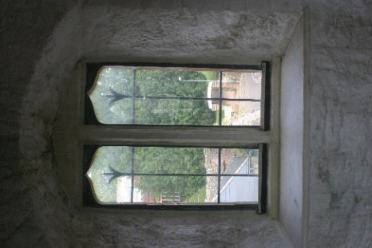
- The Coverdale Tower, or
- The Bible Tower.
I then go on to explain that until relatively recently, local people liked to tell of Miles Coverdale, at one time Bishop of Exeter, who was seen in candlelight at night, working in the Tower on his translation of the Tyndall Bible from Latin into English.
Then I scoff and tell them that is a load of rubbish as it is a known fact that Coverdale was in Flanders at the time his translation of the Bible into English was published, and that there was no way he could have been working on his translation in Paignton – the dates just do not tally.
I now must eat humble pie and admit the story MIGHT have an element of truth!

The Saxon manor of Peintone (Paignton) became the personal property of the Bishop of Exeter in 1049 (17 years before the Norman conquest) and remained part of all subsequent bishops estates for the next 500 years.
Since the mid 1500s, the story of Miles Coverdale, Bishop of Exeter, sitting in his Tower at night, at work on his translation and correction of Tyndall’s English Bible was passed by word of mouth onto the next generation of Paigntonians. The story was generally accepted for about 450 years until 20th century researchers pointed out that Coverdale spent considerable periods abroad whilst rewriting Tyndall’s work, and they believed there was no evidence to show Coverdale was anywhere near Paignton when his version of the Bible was printed in 1535.
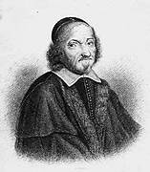
Briefly, Coverdale is thought to have been born near Middleham, Yorkshire in 1488 and entered Cambridge University to study philosophy and theology. He ordained as a priest at Norwich in 1514, then in 1523 entered the convent of Augustinian friars at Cambridge, where he met a prior called Robert Barnes who introduced him to the Protestant ideas of Calvin and Luther – the ‘New’ Religion as it was becoming known. When Barnes was tried for heresy in 1526, Coverdale assisted in his defence, then promptly left the convent of friars to give himself entirely to preaching. Coverdale and Barnes had researched the works of Augustine, which led them to the bible where they had made a thorough study of the scriptures and, in doing so, had encouraged many other students and ministers of the church to look more deeply into Christianity and Biblical theology.
At Thomas More’s house, Coverdale met Thomas Cromwell, who became a good friend and supporter. Coverdale also became involved in a secret group which met at a place called the ‘White Horse Tavern’ where many theological questions were discussed in secret. The first English translation of the New Testament was written by Tyndall secretly in Hamburg and printed in Worms in 1526. It is said this Bible, initially 15,000 copies, was smuggled into England in bales of merchandise, sold very cheaply, and proved very popular throughout the country. However, the convocation (a higher order of English bishops) were none too happy with the problems that might follow this publication, so the Mayor of London (Cuthbert Tonsall) bought up every copy and had the lot publicly burnt. It became very dangerous to hold Protestant views in England, and in 1528, Coverdale was informed against and because he was in danger of being burnt for heresy, he quickly left for Europe where he met and listened first hand to two eminent reformers, Martin Luther (left) and John Calvin (right).
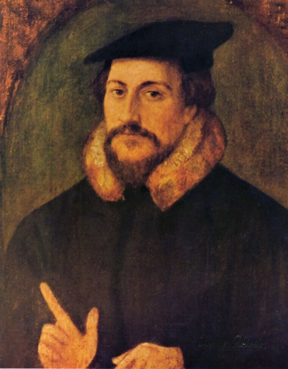
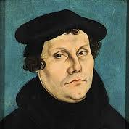
Between 1528 and 1535, Coverdale spent most of his time in exile in continental Europe, mainly in Antwerp. There he worked on revisions to Tyndall’s version of the bible and it is believed that the Coverdale Bible was printed in Antwerp and finished on 4th October 1535. If this is correct, the good people of Paignton would not have been able to gaze up at our Tower to see Coverdale at work.

By 1548, Coverdale was back in favour and had returned to England. On 14th August 1551, on the King’s authority, Miles Coverdale was consecrated as Bishop of Exeter by Archbishop Cranmer at Croydon. On taking up his post in Exeter following his first sermon on the new faith, two attempts were made to poison him, and Coverdale was also horrified to discover the Exeter Cathedral had been virtually stripped clean of anything of value.
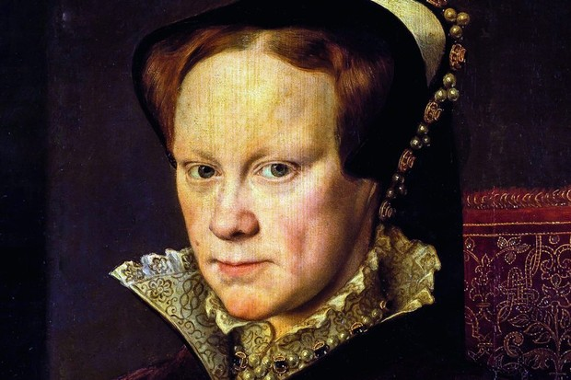
In 1553, Edward VI died of tuberculosis and was succeeded by Queen Mary, daughter of Henry VIII. Mary followed the Catholic faith, but upon her accession to the throne she was pressured into giving up the Mass and to acknowledge the English Protestant faith. Her conversion was not long lived, and soon Mary was intent on returning England to Catholicism. The crime of heresy was regarded as an offence amounting to treason, as it meant you were against the religion of the Sovereign and so were disloyal. This led to hundreds of Protestants being accused of heresy and put to death by burning at the stake, leading many who opposed her to refer to her as ‘Bloody Mary’.
Mary took the bishopric away from Miles Coverdale on account of his Calvanistic preaching. He had taken a wife which, under the Catholic faith, was an unlawful marriage. Mary imprisoned Coverdale, although where is not known and he remained imprisoned for two and a half years.
At this time in English history, it was considered proper for imprisonment to be at a place suitable for your rank in society. Nobility would be imprisoned under house arrest in a noble’s castle, common prison would be for the common man (and at that time, prisons were bursting at the seams). So where to imprison Coverdale? – son of an ordinary Yorkshire man, and a man of the cloth. At that time, feeling in the west was strongly pro the Catholic faith, and in Paignton, Coverdale was not popular with the ordinary people who could not accept him because he preached the Gospel in English and because he had broken the celibacy law of the Catholic faith and taken a wife. The Vicar of the Parish of Paignton was Cannon Lawson – a man bitterly opposed to his former Bishop. This, coupled with the public opinion against Coverdale, could have made Paignton seem a safe place to imprison the troublesome preacher.
By this time it is recorded that the Bishop’s Palace was in a state of decay, although the Great Stable was still said to be habitable and was indentured to a Richard Churchward. However the Tower remained a strong fortification, which could quite easily be guarded to provide a secure prison.
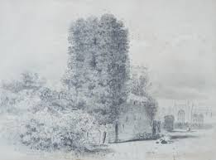
Is it possible that a legend which survived for almost 450 years, passed down through generations of Paigntonians, was true, if a little skewed by the re-telling.
The Coverdale Bible was printed in 1535, and Coverdale was imprisoned in 1553 – an easy mistake to confuse 35 with 53.
Could the good people of Paignton have seen Coverdale imprisoned in the Tower at night, still working on his religious tracts by candlelight, and told their children they ‘saw Miles Coverdale, the translator of the bible, imprisoned there’, rather than they ‘saw Miles Coverdale translating the bible up there’?
It is said that Coverdale was frequently questioned on his beliefs and in constant peril of death, but strangely came to no harm. This may be due to his wife’s connections with King Christian III of Denmark, as Christian pleaded with Queen Mary to release Coverdale and eventually in 1555 Coverdale was granted freedom and a safe passage to Denmark. He and his family joined the hundreds of people fleeing England at this time. He busied himself on a translation of Calvin’s treatise on the Eucharist and preached amongst the English refugees.
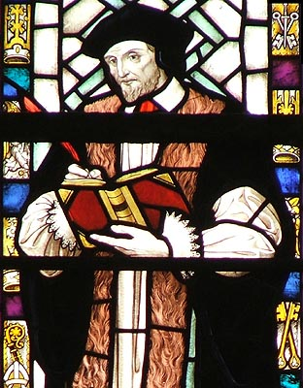
In 1558, the reign of ‘Bloody Queen Mary’ ended with her death, and in 1559 Coverdale returned to England. He was offered back his bishopric, but refused. In February 1568 he died, still a preacher and still attracting large audiences.

Karen Chapman
February 2026

References:
The Legend of Coverdale Tower – Peggy Parnell
Paignton’s Bishops Tower and Palace, A Background History – Len Harwood
Miles Coverdale - Wikipedia

